Design patterns
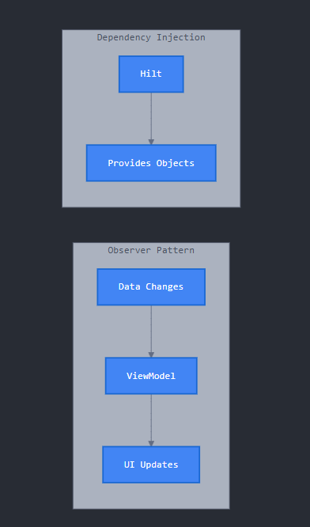 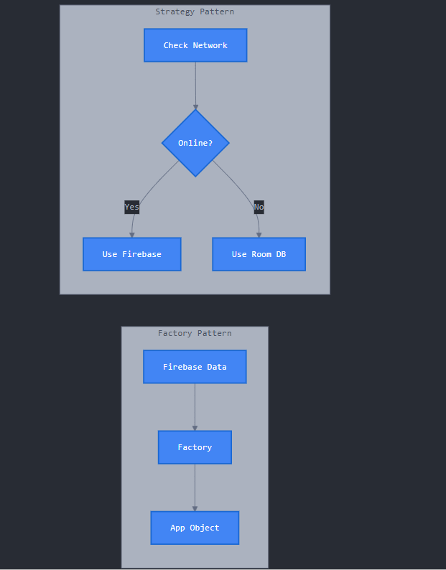 (Anthropic, 2025)
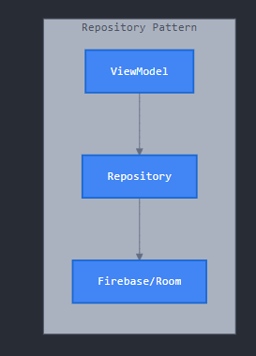 Figure 6: (Anthropic, 2025)
This diagram shows 5 design patterns that make your app code clean and professional. Repository Pattern creates a middle layer between your UI and database (Firebase/Room), so changing databases later is easy. Factory Pattern safely converts raw Firebase data into proper app objects with validation. Strategy Pattern automatically switches between online (Firebase) and offline (Room DB) modes based on internet connection, so the app works anywhere. Observer Pattern makes the UI automatically update whenever data changes in Firebase without manual refresh - when a teacher marks attendance, parents see it instantly. Dependency Injection (Hilt) automatically provides objects when needed, reducing code and making testing easier. Together, these patterns ensure your app is maintainable, testable, works offline, has real-time updates, and follows industry best practices used by professional developers. (Anthropic, 2025)
Referencing
Anthropic. 2025. Claude Code (Version 1.0). [Large language model and code assistant]. Available at: https://www.anthropic.com/claude-code [Accessed: 13 October 2025].

